# Archer DORA-Aligned Register of Information

The Digital Operational Resilience Act (DORA) is a regulatory framework introduced by the European Union to ensure the operational resilience of financial institutions and critical infrastructures in the face of digital disruptions, such as cyberattacks or IT failures. This regulation also affects non-European companies doing business in Europe. As part of DORA, financial entities must maintain and report specific operational data to ensure compliance and improve resilience.

The Archer DORA-Aligned Register of Information captures third party data points making up the Register of Information.

On this page

* Release notes
* Overview
  + Key features and benefits
  + Prerequisites (ODA and system requirements)
  + Compatible use cases and applications
    - Related applications
    - Impacted use cases
    - Additional resources
* Offering components
  + Architecture diagram
  + Applications
  + Personas and access roles
* Installing Archer DORA-Aligned Register of Information App-Pack
  + Security considerations
  + Installation overview
    - Task 1: Prepare for the installation
    - Task 2: Install the package
  + Installing the package
    - Task 1: Back up your database
    - Task 2: Import the package
    - Task 3: Map objects in the package
    - Task 4: Install the package
    - Task 5: Review the package installation log
    - Step 4: Test the installation
* Configuring Archer DORA-Aligned Register of Information App-Pack
* Using Archer DORA-Aligned Register of Information App-Pack
* Certification environment

## Release notes

| Release Date | Archer Platform Release | Notes |
| --- | --- | --- |
| February 2025 | 2024.09 | Initial Release |

## Overview

### Key features and benefits

The Archer DORA-Aligned Register of Information app-pack enables organizations to:

* Track all ICT service providers and their contractual details
* Monitor critical service provider risks
* Track and verify compliance activities
* Export and format reports to meet DORA’s specific documentation requirements for Excel

The Archer DORA-Aligned Register of Information app-pack provides the following benefits:

* Provides clear evidence for auditors to simplify compliance reviews
* Demonstrates proactive risk management for critical vendors
* Strengthens overall governance through comprehensive vendor assessments
* Ensures regulatory adherence and preparedness for inspections
* Adhere to DORA’s specific documentation requirements

### Prerequisites (ODA and system requirements)

The following table lists the components and prerequisites for the Archer DORA-Aligned Register of Information app-pack.

|  |  |
| --- | --- |
| Components | Prerequisites |
| Archer Solution Area(s) | Third Party Management |
| Archer Use Case(s) | Third Party Catalog |
| Archer Applications | Third Party Profile |
| Uses Custom Objects | Yes. For the best user experience in SaaS, the platform should use the classic UI. |
| Requires Archer License | Additional licensing fees apply for the Archer Australian Regulatory Correspondence app-pack. Please contact Archer Sales Representative for more information and pricing. |
| Archer Platform Requirements | Archer Platform Release 2024.09 and later |
| Supported Archer Environments | * On-Premise * SaaS * **Note:** Archer SaaS clients can utilize this offering; however, since the application includes custom objects, the platform should be in legacy record view to support them. |
| Partner/Vendor Requirements | N/A |

### Compatible use cases and applications

The following table shows additional features that are available if you have the specified use cases licensed.

For information on these Archer use cases, see the [Archer Solutions Help](https://help.archerirm.cloud/archer_suite_help/en-us/Content/PortalHome/SolutionsHome/sol_home.htm).

#### Related applications

The following table lists the related applications for the Archer DORA-Aligned Register of Information app-pack.

|  |  |  |
| --- | --- | --- |
| Application | Use Case | Primary Purposes of the Relationship |
| Third Party Profile | Third Party Catalog | Register information is created against every Third Party Profile |

#### Impacted use cases

The following table lists the impacted use cases for the Archer DORA-Aligned Register of Information app-pack.

| Archer Use Cases |
| --- |
| Third Party Catalog |

#### Additional resources

The following additional resources are available for this offering:

* [Digital Operational Resilience Act (DORA) - EIOPA](https://www.eiopa.europa.eu/digital-operational-resilience-act-dora_en)

## Offering components

### Architecture diagram

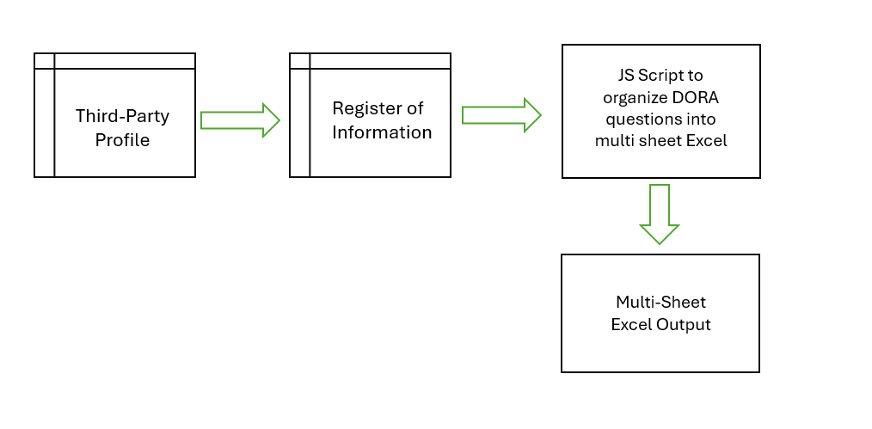

### Applications

The following table describes the Archer DORA-Aligned Register of Information app-pack applications.

| Application | Description |
| --- | --- |
| Register of Information | This application provides container of information aligned with DORA requirements. The application can also generate an excel with all the input provided. |

### Personas and access roles

The following table describes the functions that make up the application’s organization roles. Depending on the organization of your company, these functions and responsibilities may vary.

| Persona | Description |
| --- | --- |
| ROI DORA: Relationship Manager | Inherited from Third Party Profile |
| ROI DORA : Procurement / Legal Officer | Inherited from Third Party Profile |

## Installing Archer DORA-Aligned Register of Information App-Pack

### Security considerations

The information in this publication is provided "as is". Archer makes no representations or warranties of any kind with respect to the information in this publication, and specifically disclaims implied warranties of merchantability or fitness for a particular purpose. Client is solely responsible for ensuring that the installation of the application is performed in a secure manner. Archer recommends clients perform a full security evaluation prior to implementation.

### Installation overview

Complete the following tasks to install the Archer DORA-Aligned Register of Information App-pack.

#### Task 1: Prepare for the installation

1. Ensure that your Archer system meets the following requirements:
   * [Archer Platform version 2024.09 and later].
2. Read and understand "Packaging Data" in the [Archer Platform Help](https://help.archerirm.cloud/archer_suite_help/Default.htm).

#### Task 2: Install the package

Installing a package requires that you import the package file, map the objects in the package to objects in the target instance, and then install the package.

### Installing the package

#### Task 1: Back up your database

There is no Undo function for a package installation. Packaging is a powerful feature that can make significant changes to an instance. Back up the instance database before installing a package. This process enables a full restoration if necessary.

An alternate method for undoing a package installation is to create a package of the affected objects in the target instance before installing the new package. This package provides a snapshot of the instance before the new package is installed, which can be used to help undo the changes made by the package installation. New objects created by the package installation must be manually deleted.

#### Task 2: Import the package

1. From the menu bar, click Admin menu > Application Builder > Install Packages.
2. In the Available Packages section, click Import.
3. Click Add New, then locate and select the package file that you want to import.
4. Click OK.

* The package file is displayed in the Available Packages section and is ready for installation.

#### Task 3: Map objects in the package

**Important:** This step is required only if you are upgrading to a later version of the offering.

1. From the menu bar, click Admin menu > Application Builder > Install Packages.
2. In the Available Packages section, locate the package you want to map.
3. In the Actions column, click Map package for that package.

* The analyzer examines the information in the package. The analyzer automatically matches the system IDs of the objects in the package with the objects in the target instance and identifies objects from the package that are successfully mapped to objects in the target instance, objects that are new or exist but are not mapped, and objects that do not exist (the object is in the target but not in the source).
* When the analyzer is complete, the Advanced Package Mapping page lists the objects in the package file and corresponding objects in the target instance.

1. On the Advanced Mapping page, click to open each category and review the icons next to each object to determine which objects you must map manually.

The following table describes the icons.

| Icon | Name | Description |
| --- | --- | --- |
| Awaiting mapping review | Awaiting Mapping Review | Indicates that the system could not automatically match the object or one of its children to a corresponding object in the target instance.  Objects marked with this icon must be mapped manually.  New objects should not be mapped. Select Do Not Map from the drop-down menu to clear this icon for an individual object, or click Do Not Map to clear the icon for all unmapped objects. |
| Mapping completed | Mapping Completed | Indicates that the object and all children are mapped to objects in the target instance, or that they have been marked as Do Not Map. Nothing more needs to be done with these objects in Advanced Package Mapping. |

* **Note:** You can run the mapping process without mapping all objects. The Awaiting mapping review icon is for informational purposes only.

1. For objects awaiting mapping review, do one of the following:
   * To map each object individually, use the drop-down menu in the Target column to select the object in the target instance to which you want to map the source object. To leave an object unmapped, select Do Not Map in the Target column.
   * To automatically map all objects in a category that have different system IDs but the same object name as an object in the target instance, click Auto Map. Select whether to ignore case and spaces when matching object names. Click OK.
   * To mark all unmapped objects as Do Not Map, click Do Not Map.
2. (Optional) Click Filter to enable filter fields that you can use to find specific objects in each mapping category. To undo your mapping selections, click Undo, then select whether to undo all mappings in the category or only the mappings on a single page. If you choose to undo all mappings, you will be returned to the categories list.
3. (Optional) To save your mapping selections and return to the categories list without committing changes to the target instance, click RSA.
4. After you review and map all objects, click Execute.
5. Select I understand the implications of performing this operation. Click OK.

* When the mapping is complete, the Import and Install Packages page displays.
* **Important:** Advanced Package Mapping modifies the system IDs in the target instance. You must update any Data Feeds and Web Service APIs that use these objects with the new system IDs.

#### Task 4: Install the package

1. From the menu bar, click Admin menu > Application Builder > Install Packages.
2. In the Available Packages section, locate the package file that you want to install, and click the file name or Import at end of the row to open the Options menu.
3. In the Selected Components section, click the Lookup button to open the Package Selector window.
   * To select all components, select the top-level checkbox.
   * To install only specific global reports in an already installed application, select the checkbox associated with each report that you want to install.

* **Note:** Items in the package that do not match an existing item in the target instance are selected by default.

1. Under the Translation Option drop-down menu, select an option for each selected component. To use the same Translation Option for all selected components, select a method from the top-level drop-down list.  
   **Note:** The Translation Option is enabled only when a language is selected.

The following table describes the options.

| Option | Description |
| --- | --- |
| Full Install | Installs the component and its translations from the selected languages. |
| Translations Only | Only installs the translations from the selected languages. |

1. Under the Install Method drop-down menu, select an option for each selected component. To use the same Install Method for all selected components, select a method from the top-level drop-down list.

The following table describes the options.

| Option | Description |
| --- | --- |
| Create New Only | Only creates new fields and other elements in the applications, questionnaires, workspaces, data feeds, and dashboards specified in the package file. This option does not modify any existing elements on your instance of Archer. This is useful when you want to add functionality to an existing application, questionnaire, workspace, dashboard, data feed, or access role, but you do not want to risk making any unwanted changes to the existing elements of workspaces, data feeds, or dashboards. iViews that are not currently on the dashboards that are selected for the package install are created.  **Note:** The Create New Only option does not apply to access roles or languages. |
| Create New and Update | Updates all elements in the applications, questionnaires, workspaces, data feeds, and dashboards as specified in the package file. This includes adding new elements and updating existing elements. Existing iViews on the dashboards that are selected for the package install are updated, and iViews that are not currently on the dashboards that are selected for the package install are created.  **Note:** The Create New and Update option does not apply to access roles or languages. |

1. Under the Install Option drop-down menu, select an option for each selected component. To use the same Install Option for all selected components, select an option from the top-level drop-down list.

The following table describes the options.

| Option | Description |
| --- | --- |
| Do not Override Layout | Installs the component, but does not change the existing layout. This is useful if you have a lot of custom fields and formatting in your layout that you do not want to risk losing.  You may have to modify the layout after installing the package to use the changes made by the package.  **Note:** The Do not Override Layout option does not apply to access roles or languages. |
| Override Layout | Updates the layout as specified in the package file, overwriting the existing layout.  **Note:** The Override Layout option does not apply to access roles or languages. |

1. Click Continue to advance to the next object category in the Package Selector, and repeat steps 4 to 6. After reviewing all object categories, click OK.
2. To deactivate target fields and data-driven events that are not in the package, in the Post-Install Actions section, select the Deactivate target fields and data-driven events that are not in the package checkbox. To rename the deactivated target fields and data-driven events with a user-defined prefix, select Apply a prefix to all deactivated objects, and enter a prefix. This can help you identify any fields or data-driven events that you may want to review for cleanup post-install.
3. Click Install.
4. Click OK.

#### Task 5: Review the package installation log

1. From the menu bar, click Admin menu > Application Builder > Install Packages.
2. In the Package Installation Log section, click the package that you want to view.
3. In the Package Installation Log page, in the Object Details section, click View All Errors.

* **Note:** To view individual logs, in the Errors column of the log you want to view, click the Failures link or Warnings link. Clicking View All Errors, Failures, or Warnings opens the specific errors on a different page.

1. Click the Export icon to export the log file.
2. Click Close.

For a list of packaging installation log messages and remediation information for common messages, see Package Installation Log Messages.

#### Step 4: Test the installation

Test the application according to your company standards and procedures, to ensure that the use case works with your existing processes.

## Configuring Archer DORA-Aligned Register of Information App-Pack

Follow the steps below:

1. Create a Values list in Third Party Profile Application name Dora Reporting.
2. The Values List should be configured as Checkbox.
3. Add a value Yes.
4. Create a Tab named "Register of Information" in the default tab set.
5. In the newly created tab create a section named "Register of Information".
6. Add the Register of Information cross-reference field in that section.
7. Inside the "Always True" Rule in the rule tab modify the action "Hide Conditional Layout Objects" and make the Register of Information section hidden and save the action.
8. Go to Rule Tab, create a new Rule named "Show Register of Information".
9. In the Criteria section add "Dora Reporting" field and operator should be contains and, in the values select Yes.
10. In the Associate Action Section Add a new Action.
11. Name the action as "Display Register of Information" select the type "Apply Conditional Layout".
12. Select display in the section property for Register of Information.
13. Under Qualified User/Group select everyone and save the Action.
14. Save the Rule.

The table in the terminology section under Register of Information application comes with a default value in the Description / Internal definition of the option column. This table holds the organization specific description for each value of specific values list field. In the final export the section will be exported.

Follow the steps below to update the description as per your organization's requirement.

1. Open the Register of Information application under application builder and go to Layout tab.
2. Scroll to the section Custon Object and open the ROI Export JS custom object.
3. In the custom object properties section modify the terminologyDescription variable. Change the default description value to what is suitable for your organization for each key as shown below. The key pattern is <<fieldId>>_<<FieldLable>>_<<ValuesListValue>>:<<Your Description>>.
4. Save the changes in the custom object.
5. Save the layout.

## Using Archer DORA-Aligned Register of Information App-Pack

1. In the Third Party Profile application select Yes in Dora Reporting field.
2. Register of Information Section should then be visible.
3. Click add new in the Register of Information cross reference field.
4. In the Register of Information form opens up.
5. In the form the ROI status field by default contains Draft value, it allows the users to partially fill the Register of information for a specified Third Party.
6. When the Complete information is available, user can select ready for reporting which will display all the required fields.
7. Once the entire form is filled and saved an export button displays in the hamburger menu on the top right of the page.

* Here is a sample of the report.
* 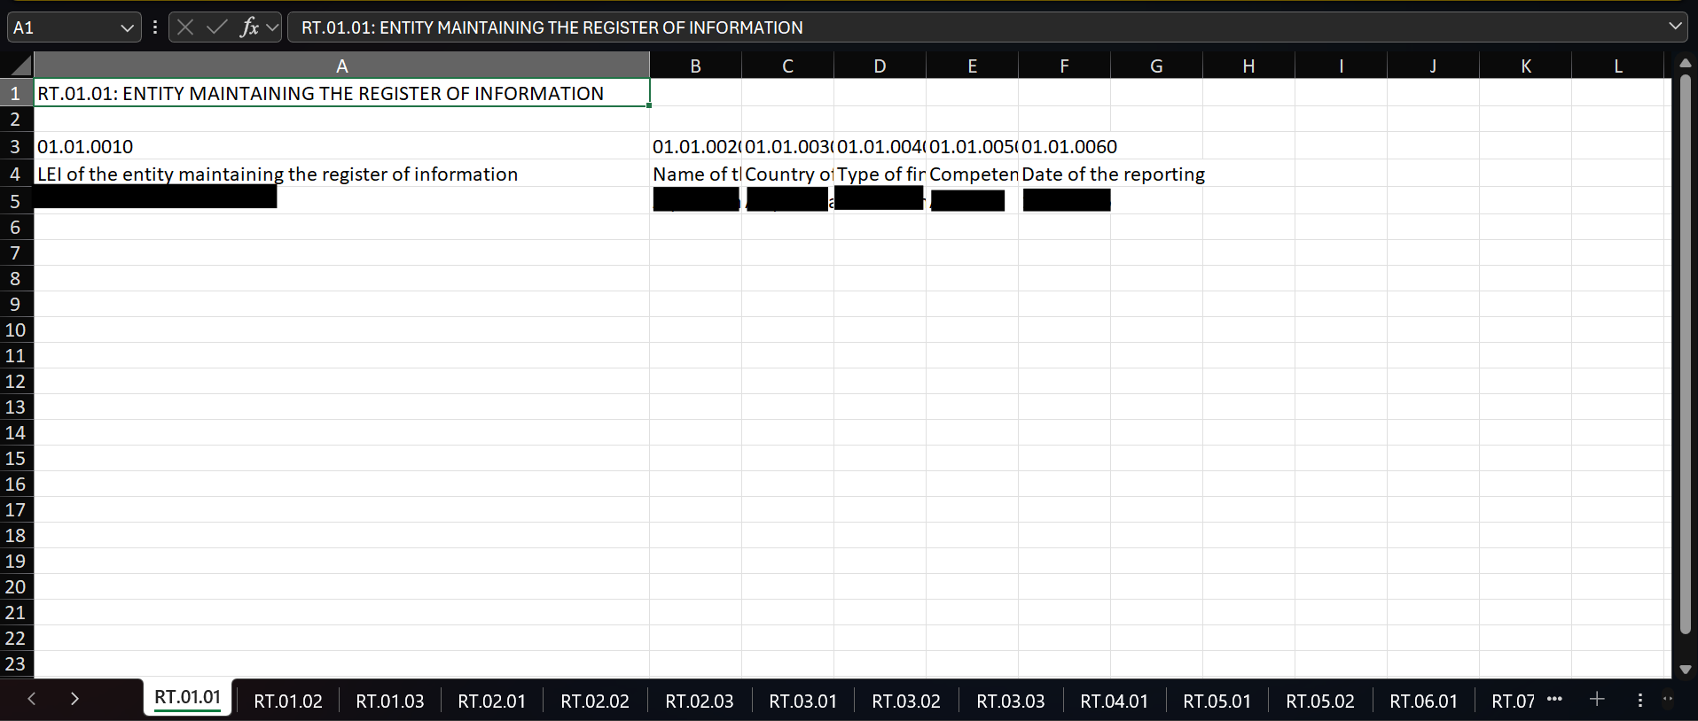

## Certification environment

Date tested: January 2025

|  |  |  |
| --- | --- | --- |
| Product Name | Release Information | Operating System |
| Archer | 2024.09 | Virtual Appliance |